Registration is now open for summer recreation baseball and softball leagues
Summer Recreation Baseball & Softball Registration
Little Turks T-Ball (age 4-6 / Co-ed): $50.00 Resident–NOT OPEN YET
6U Modified Coach Pitch (Co-ed): $50.00 Resident
Boys 8 & under / Girls 8 & under: $75.00 Resident
Boys 10 & under / Girls 10 & under: $85.00 Resident
Boys 12 & under / Girls 12 & under: $85.00 Resident
Please note: additional $25.00 fee charged for non-resident
Registration ends 4/15/2022 due to shirt order processing

* Register online at www.tremontpark.org (please note there is a 3% processing fee)
* Use this form and attach a check, and mail to the park district office or drop the registration form & check in the drop box (forms also available above drop box) located inside the entry of the main park district office located at 22522 IL Route 9 (inside the fitness center)
* Stop in during staffed hours to complete a form and make payment.
*Watch website and Facebook for T-ball registrations

Complete and detach form below Don’t forget to sign and date the back!

Retain top of form for information about the program

NEW: Girls 8u and up will be required to have an infield face mask before first practice.

Tremont Parks & Recreation Center – 2022 Registration Form

Parent Name ______________________ Email ______________________________
Address ___________________________ City ________________ Zip ___________
Home # _____________________ Cell # ________________ Work #_____________
Emergency Contact: __________________ Phone # _________ Relationship ________
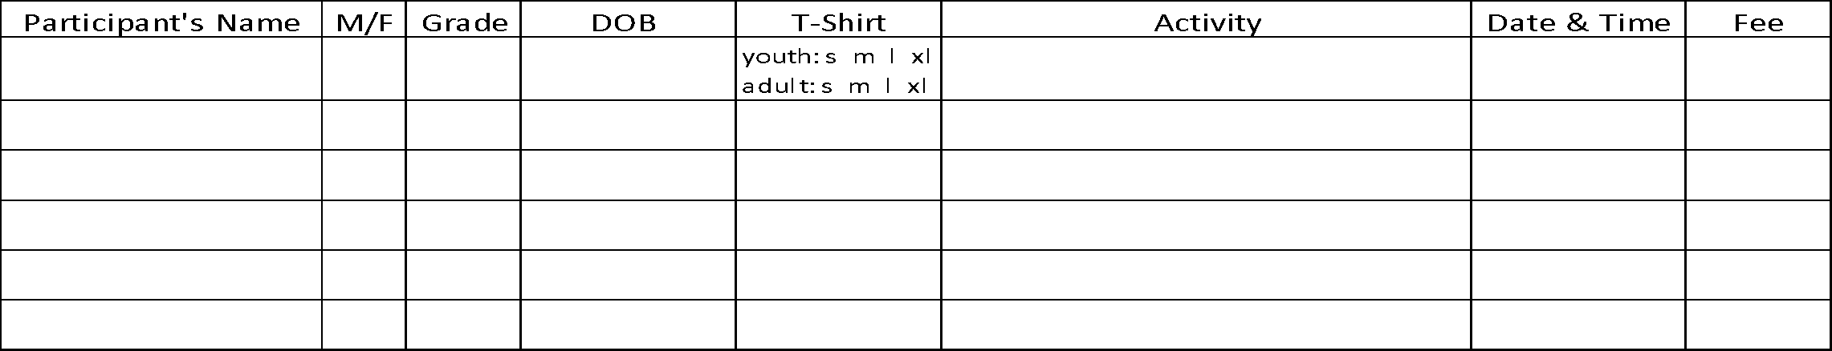
Are you interested in coaching or helping? Yes ____ No _____Circle shirt size: Adult S M L XL XXL
*****ALERT***** Please list any allergies or special needs: ________________________________________

PAID: cash or check # ___________ Total fees: ________

*Once registration is completed, we will establish an evaluation date for those leagues with multiple teams (with the exception of Little Turks T-Ball and 6u Modified Coach Pitch). We ask that registration forms be turned in as soon as possible . If you are interested in coaching one of the recreation teams, please indicate that on your registration form. Tremont Area Park District intends to allow all children the opportunity to participate. If fees are a concern, please let us know and confidential arrangements will be made.
Staffed Hours:
Mon Tues Wed Thurs Fri: 8am-12pm and 3pm-6pm
Wednesday: 3pm-6pm
Saturaday: 8:30am-11am
*Eligibility is based on the child’s age as of May 1st for boys and January 1st for girls. Teams will be formed for ages 4-12 depending on interest. The Little Turks T-Ball & 6U Modified Coach Pitch are co-ed teams.

22522 IL Route 9
Tremont, IL 61568
(309) 925-3811
Email: tapdfacres@gmail.com
Website: www.tremontpark.org

NEW: Girls 8u and up will be required to have an infield face mask before first practice.

Sign Below

WAIVER AND RELEASE - Read Over Carefully
Please read this form carefully and be aware in registering yourself, your child or ward for participation in this program you will be waiving and releasing all claims for injuries you or your minor child/ward might sustain arising out of this program. As a participant in the program or the parent/guardian of a participant in the program, I recognize and acknowledge that there are certain risks of physical injury and I agree to assume the full risk of any injuries, including death, damages or loss which I or my minor child/ward may sustain as a result of participating in any and all activities connected with or associated with such program. I agree to waive and relinquish all claims I or my minor child/ward may have as a result of participating in the program against the Park District and its officers, agents, servants and employees. I do hereby full release and discharge the Park District and its officers, agents, servants and employees from any and all claims from injuries, including death, damage or loss which I or my minor child/ward may have or which may accrue to me or my minor child/ward on account of my participation in the program. I further agree to indemnify and hold harmless and defend the Park District and its officers, agents, servants and employees from any and all claims resulting from injuries including death, damages and losses sustained by me or my minor child/ward and arising out of, connected with or in any way associated with the activities of the program. In case of accident or sickness, I consent to emergency medical care provided by ambulance or hospital personnel. I hereby consent to the use of my photograph in the Park District brochures, publications, slide presentations, etc.
I have read and fully understand the above Registration Policies and Procedures and Waiver and Release of all Claims.

Signature of Parent/Guardian ________________________________________ Date ___________________

